https://vm-graphite01p.tcsbank.ru/d/5Lk7a3jWk/vcs-status-general?orgId=1
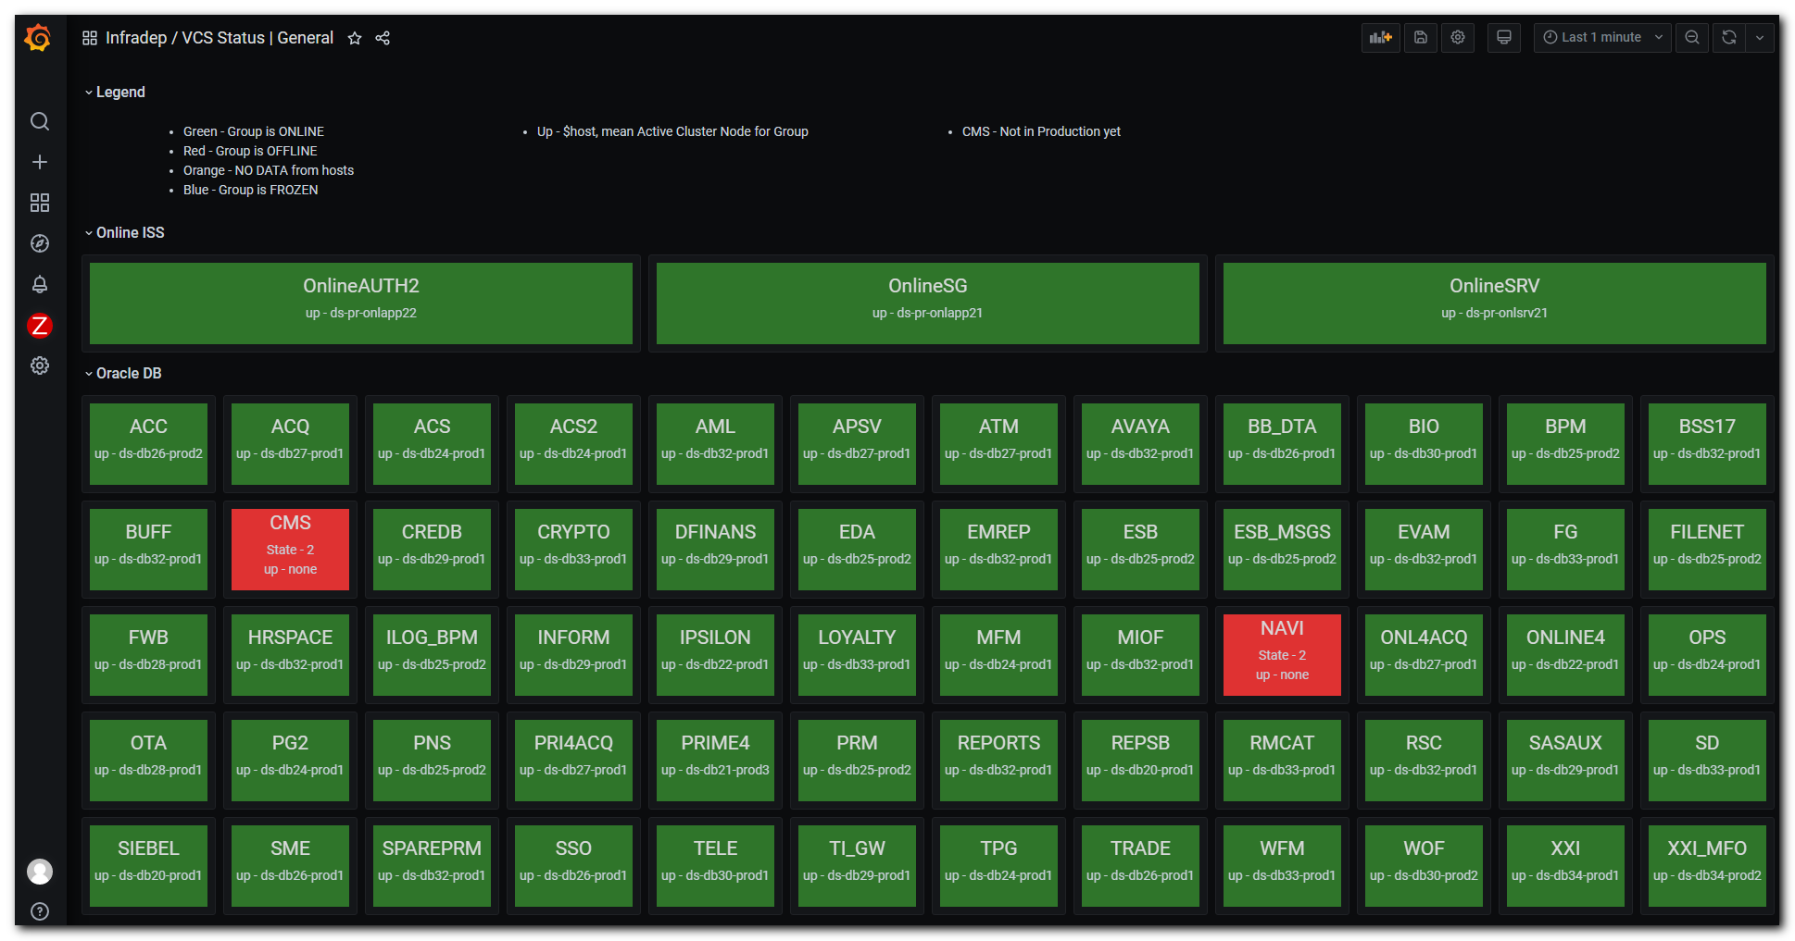

https://ui.sage/grafana/d/iJHB2mrGz/bird-exports?orgId=322
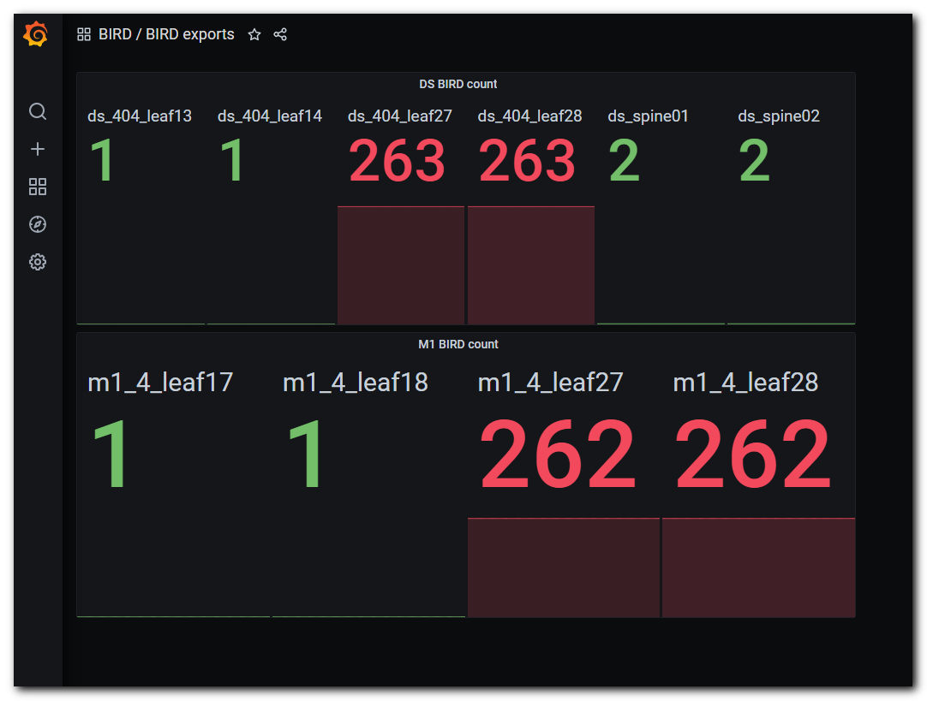
https://tinkoff.slack.com/archives/CTRAME9LP/p1619448699215600
